# Project Name: SA Decorations

# Project type: Final Project Documentation

# By Ankur

Acknowledgements

This project has taken a good amount of time and material and I would like to acknowledge the help of all of those who have made the project possible. In particular I would like to thank my supervisor for his time, patience and guidance, and also for allowing the idea to be pursued originally.

Introduction

This is the report of the website SA decorations and the project approach is to create an portal that can have all the record of SA decorations online on web and data can be smartly collected managed by this way.

1. Initial Design - The project, which were designed independently:
   1. Design of the Project - Consideration of issues such as the services re-quired, the semantics of the needed operations and the language and systems to be used.
2. Speci cation - The interfaces between the four areas were speci ed pre-cisely, and the requirements for each of the four sections were elicited.
3. Implementation - These four areas were separately implemented, mostly in .Net,. Wherever possible existing systems were used to provide the basis of the functionality.
4. Testing - The implementation from each of the four parts were then tested as a single system
5. Evaluation - The system was evaluated through comparisons to existing systems were possible and through qualitative analysis of the commercial viability of the implementation.

**Systems Analysis –** This platform was built with ASP.NET. The key feature is about booking a car for a tour and admin can add car for a tour and route there is different working for both so that website should be common to all.

The project team assessed the project's scope and devised a timetable and resource allocation strategy based on their findings.

**Systems design** – This is a high-level description of how a computer-based system would satisfy the requirements; it is expected to be a single-user system that does not rely on data connection for the primary facility.

**Systems Specifications**

OS -Windows 10

IDE- Visual Studio

**Programming** – ASP.NET and C# was used for functionality completed as a working system in an MVC model.

Step 2***:*** Produced a project proposal contained that includes home page, add product and other items page

Project Goal – Build a platform for SA decorations

Project Objectives – The main objectives of the project was to enable that users can book a tour what admin puts on the website through admin login

Project Scope – A full-fledge website develop 5 page website development

1. Context – A Admin Login Facility
2. ASP.NET language platform
3. Stakeholders of the product: People who want to book tour
4. Backend or API integration

Project Deliverables –

1. Analysis documentation
2. Design documentation
3. Executable program
4. User documentation

Resources

|  |  |
| --- | --- |
| Processor | 1 GHz |
| RAM | 512 MB |
| Disk space (minimum) |  |
| 32-bit | 4.5 GB |
| 64-bit | 4.5 GB |

ProjectMilestones

|  |  |  |
| --- | --- | --- |
| **Milestone** | **Time taken** | **Finalized** |
| Designing | 3 Days | Yes |
| Programming | 4 Days | Yes |
| Documentation | 1 day | Yes |

Home Page :

Home page containing beautiful pictures for attraction

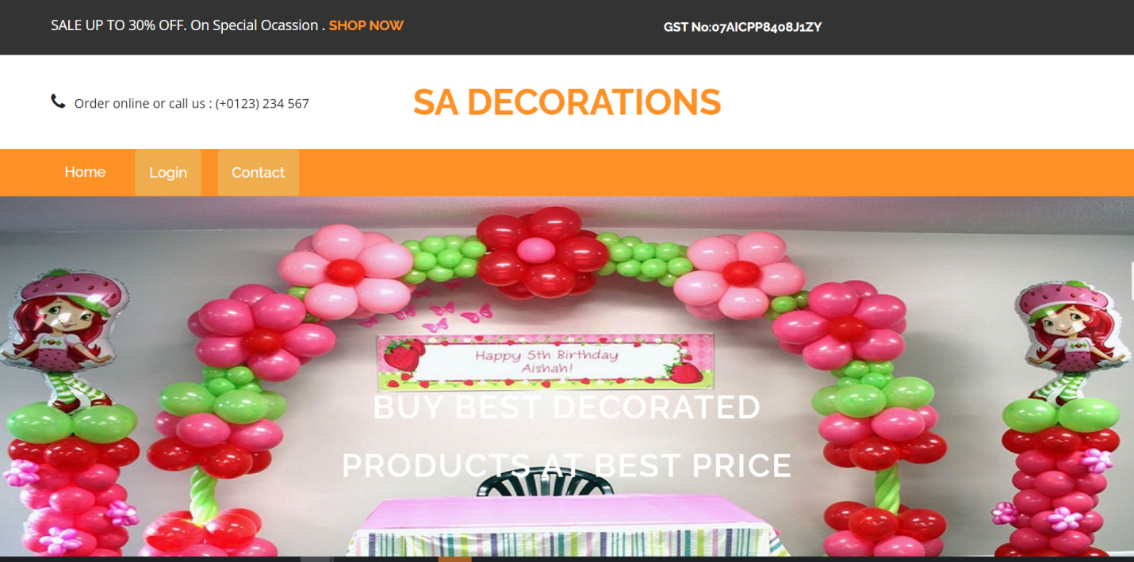

Admin can add new orders in this page

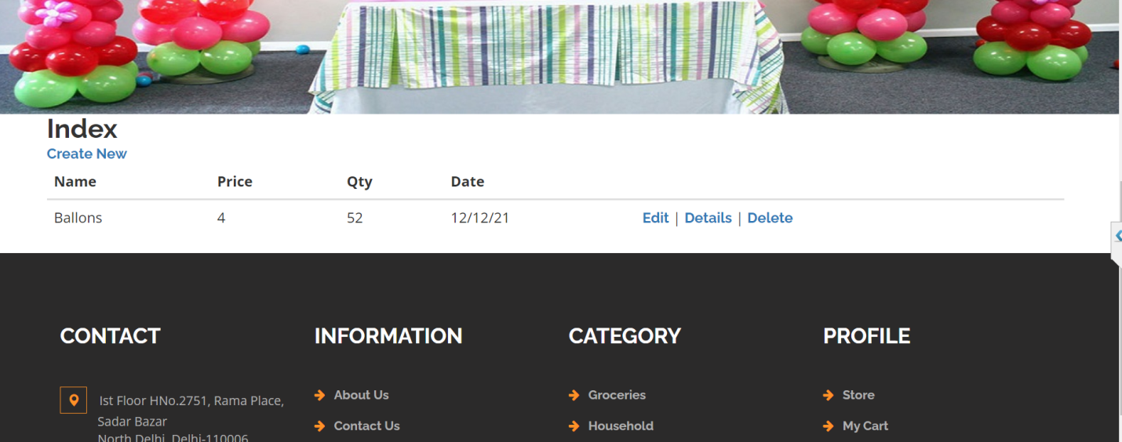

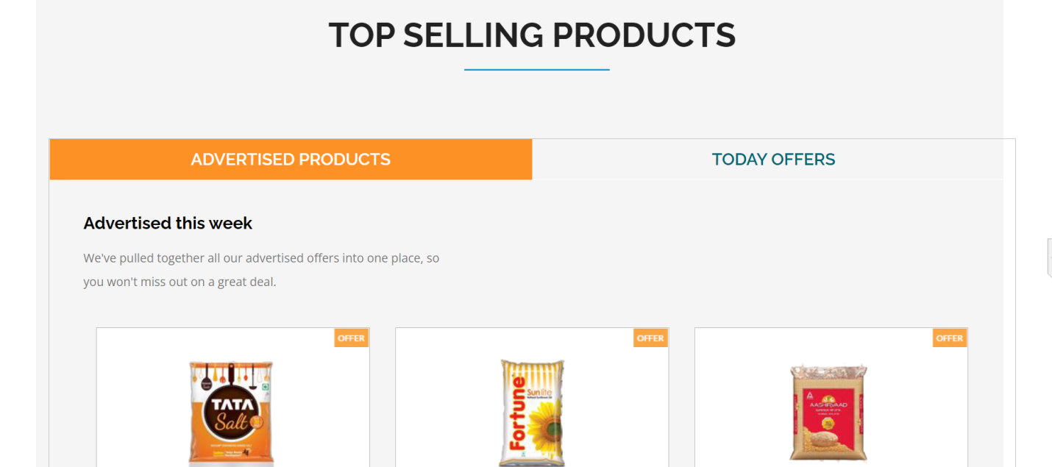

Top selling products from Homepage

Footer Section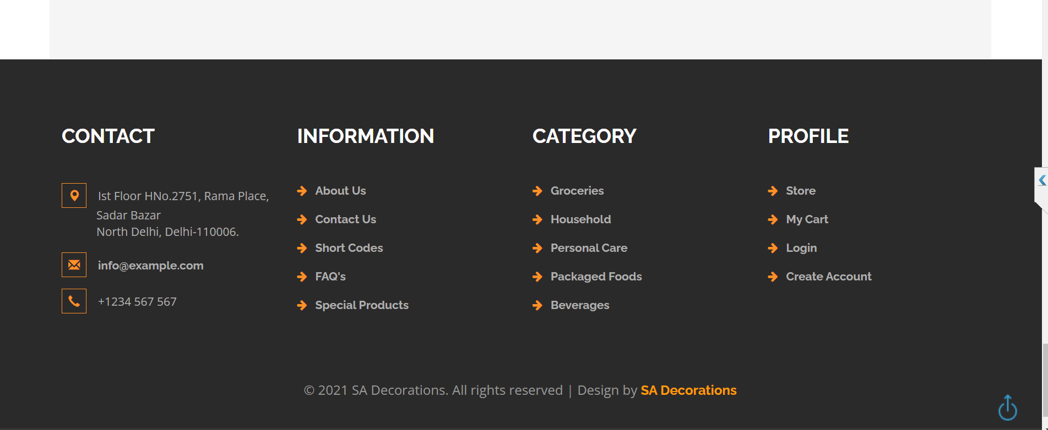

Admin Login

Email: [test@gmail.com](mailto:test@gmail.com)

Password : 12345

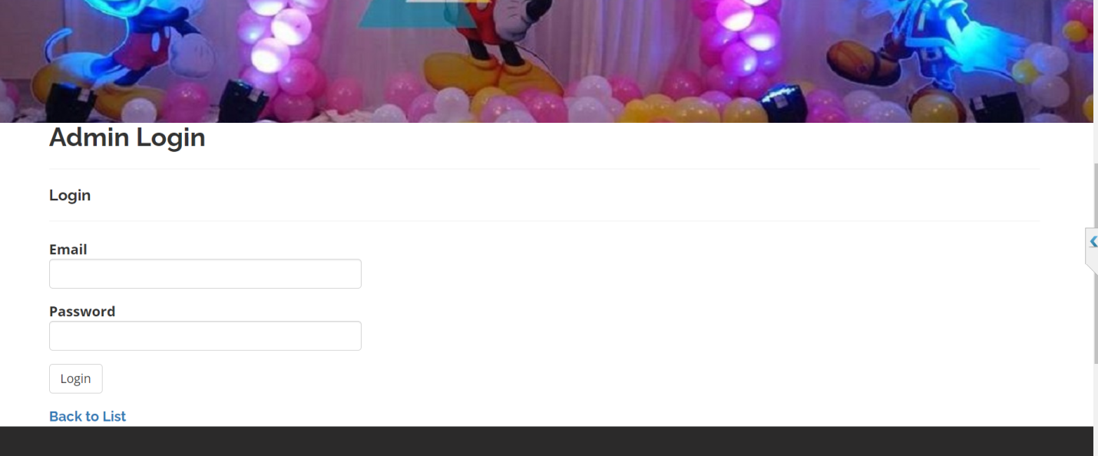

Admin Dashboard

